SWITCHING AND VLANS

- Draw a simple network diagram showing three devices (like your laptop, a friend's phone, and a smart TV) connected to a switch, and label which device is in which VLAN (e.g., VLAN 10 for streaming, VLAN 20 for personal devices).
Answer
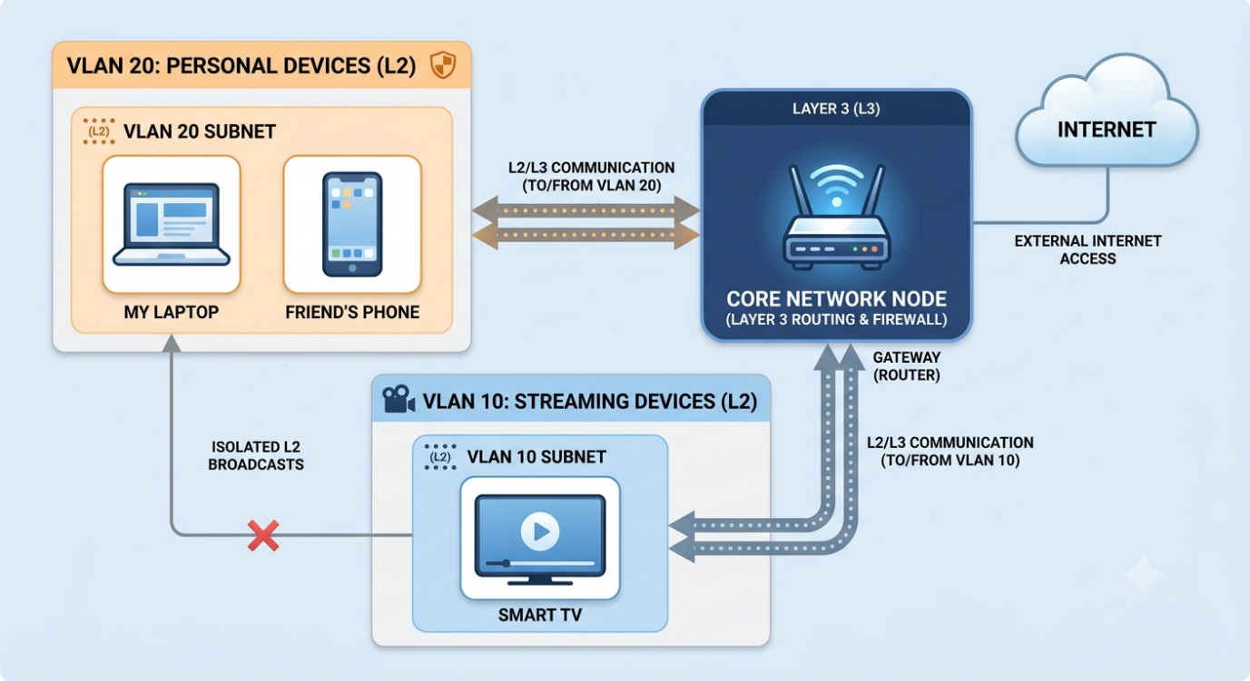

- Configure a simulated switch using Cisco Packet Tracer or NetSim: create two VLANs (VLAN 10 and VLAN 20), assign three PCs to VLAN 10 and two PCs to VLAN 20, and verify that PCs in different VLANs cannot ping each other. Use the 'vlan' and 'switchport access vlan' commands in the simulator CLI.
Answer
Quick VLAN Setup (Cisco Switch)
- Create VLANs
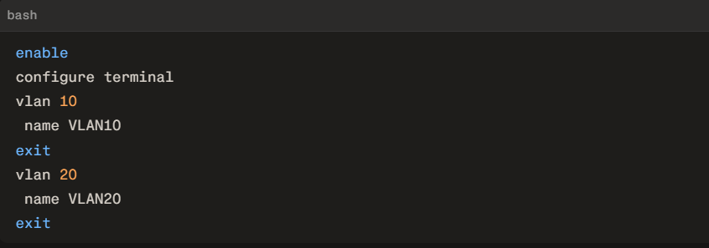

2. Assign Ports
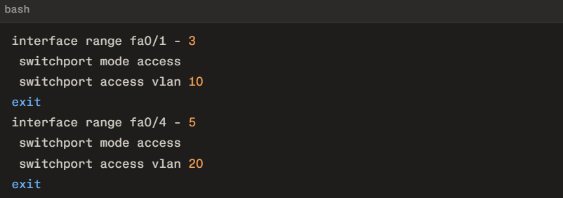
3. Verify
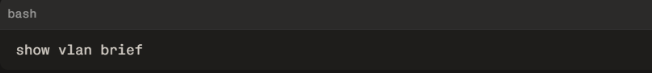
4. Test
- Same VLAN ping → ✅ Works
- Different VLAN ping → ❌ Blocked
That’s it—VLAN isolation confirmed.

- In any network simulator, set up a scenario where you move a PC from VLAN 10 to VLAN 20. Show the before and after configuration commands and test connectivity to confirm the change.
Answer
To move a PC from VLAN 10 to VLAN 20, reassign its switchport interface to the new VLAN in the switch CLI.
Assuming PC0 is connected to port FastEthernet 0/1 and has an IP address of 192.168.1.10.
1.Initial State Configuration & Baseline Test: Before Change.
Port Fa0/1 is initially assigned to VLAN 10.
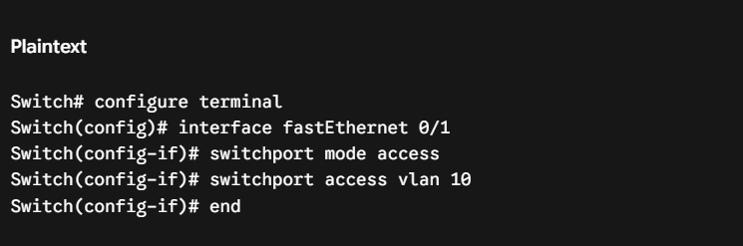
Connectivity Test:
- Ping PC1 (192.168.1.11, on VLAN 10) from PC0 -> Success (Replies received).
- Ping PC3 (192.168.1.20, on VLAN 20) from PC0 -> Fails (Request timed out).
To verify successful baseline, ensure PC0 can only ping devices within VLAN 10.
2.Reassign Switchport to VLAN 20:Switch Reconfiguration.
Reconfigure port Fa0/1 to access VLAN 20 instead.
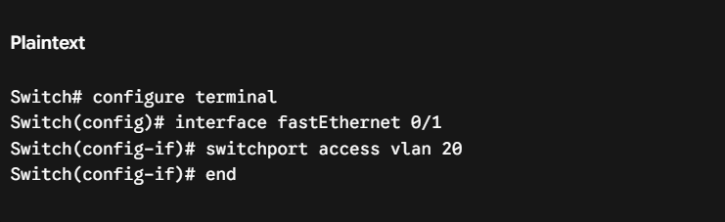
To verify the port movement, execute show vlan brief on the switch and confirm Fa0/1 is now listed under VLAN 20 instead of VLAN 10.
3.Verify Network Isolation & Connectivity: After Change.
Perform pings from PC0 again to verify that communication pathways have inverted.
Connectivity Test:
- Ping PC1 (192.168.1.11, on VLAN 10) from PC0 -> Fails (Request timed out).
- Ping PC3 (192.168.1.20, on VLAN 20) from PC0 -> Success (Replies received).
To verify successful VLAN reassignment, confirm PC0 can now ping VLAN 20 devices while losing connection to VLAN 10 devices.

- Write a short script or command list that would automate assigning 10 ports on a switch to VLAN 30, using the syntax of your chosen simulator (Packet Tracer, NetSim, or GNS3). Use a loop or range command if supported by the tool to avoid repeating the same command 10 times.
Answer
Cisco IOS syntax (works in Packet Tracer, GNS3 with real/IOS images, and most NetSim tools):
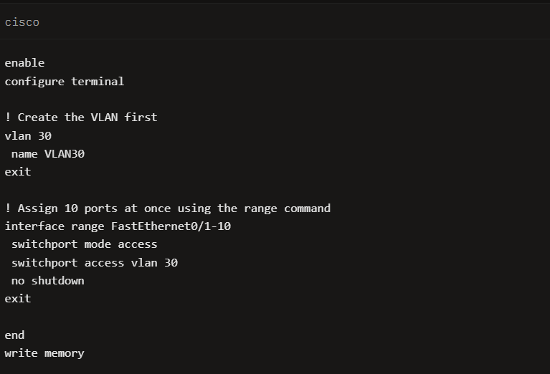
The single interface range FastEthernet0/1-10 line applies the three configuration commands to all 10 ports without repetition.

